Clare Mahon
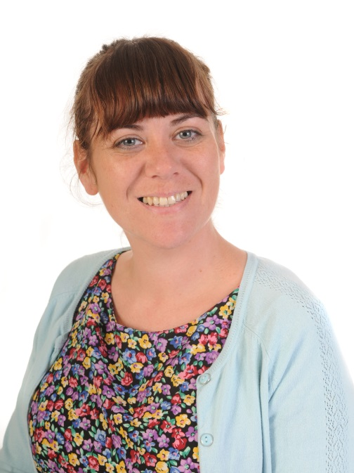
Give us a three line W5 (who what where why) style pen portrait of yourself:
Class Teacher, P5
Apart from your Class Teaching Role, do you have any special jobs in school?
PTA, Foodbank and I look after Art!
What is one of your strengths?
I’m decisive.
Are you sure about that?
Yes.
Have you ever done anything else part from teaching?
Yes, but teaching is my favourite job.
What do you do to unwind?
I like baking, cooking, yoga and crafts.
What’s your favourite sandwich?
I strongly dislike sandwiches!!
Really are you sure, beetroot and strawberry jam in a soda farl, mmm?
I’m sure.
Have you got a bike? Describe it!
I have a BMX .
What was the last movie you went to see in the cinema?
Brooklyn.
Do you have any pets?
Yes, two dogs. Zinc and Darcy.
Favourite salad?
I strongly dislike salad!
Why is Northern Ireland/Belfast brilliant?
People are great craic!
Smarties or M&Ms?
Peanut M&Ms.
Why do only fools and horses work?
??

