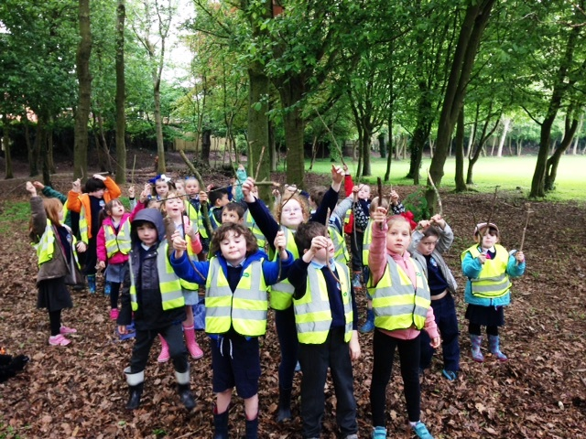
Forge Integrated Primary School
Annual Report to Parents by the Board of Governors
2019 - 2020

Principal’s Note

2019/20 started off as any school year does, with a new cohort of P1 pupils and a new set of action plans and aspirations for the school year ahead. It was also the first year of a new school development plan based on the needs identified by staff, parents, governors and the feedback we received from our pupil body.

The first term of the school year progressed well with school staff working to achieve academic and pastoral objectives embracing a comprehensive range of activities both within and beyond the classroom.
We enjoyed the usual seasonal activities around Christmas and embarked on an exciting new project with P7 pupils in January and February through the ‘Adventure Investigators’ programme which added to the outdoor and environmental education experiences our pupils enjoy.

Strategically, plans for a new school build moved forward significantly with a design team established and architects appointed to work with the school and the Education to take plans forward towards submission for planning permission.

None of us could have foreseen the extent to which the advent of Covid-19 would impact on all of our lives, and the school closure period from March to June 2020 has meant that many school activities and events that ordinarily would have occurred during that period were severely disrupted.

Aspects of assessment did not take place as children were not in school. Trips and activities had to be abandoned, learning and school life in general was diverted to a distance learning model with remote learning managed at home by parents and customary events like P7 leavers assembly transformed into a ‘drive-in’ experience.

Staff also provided cover for children of keyworkers and vulnerable children throughout the closure period and put in place risk reduction measures that set us in good stead for opening again on a full capacity basis in September.

Adapting our practices and procedures for full return to school in September in a pandemic environment has meant installing additional equipment, reviewing procedures and risk assessments and operating in an environment which is more controlled and more pressured than usual. Many ways of working which we have taken of granted for many years have been curtailed, or have had to change beyond recognition.

There is no escaping that the impact of the pandemic on parents, pupils and school staff is far reaching and we will see the effects of the period we are navigating through for some time to come.

However, with adversity comes innovation and it has been heartening to see how parents and staff have made the best of a complicated and difficult situation through flexibility, innovation and sheer tenacity.

There is no doubt that we will reflect on the Covid-19 pandemic, which is far from over at time of writing, as a landmark period in our lives. At this stage I am proud to be part of a team that has shown great resilience, adaptability and innovation in tackling the challenges it has presented and look forward to looking back on it!

Neville Watson

This report is presented under the Scheme of Management of Forge Controlled Integrated Primary School and refers to the academic year 2019 – 2020.

Membership

Boards of Governors are made up from volunteers and at Forge we have elected parent representatives, elected teacher representatives, representatives nominated by the Education Authority and representatives nominated by the Department of Education

This report spans a period where the Board of Governors was reconstituted with a newly constituted board installed in January 2019.

Forge Integrated Primary School Governors,
(constituted in 2019 and serving until 2022)

Chairperson | Mr Michael Prendergast
Vice Chairperson | Mrs Denise Toner
Designated Governor for Safeguarding | Mrs Claire Humphrey
Elected Parent Representatives | Dr Jennie Carlsten  Mr Cahir Hughes  Mr David Majury  Mrs Haxia Zhang
Elected Staff Representatives | Mrs Grainne Kerr  Mrs Joanne Mercer
Education Authority Nominees | Mrs Claire Humphrey  Mr Nicky McBride  Mrs Florence McCaw  Mrs Heather Harold
Department of Education Nominees | Mr Michael Prendergast  Mrs Catherine McKeown  Mrs Denise Toner
Secretary/ Principal (Non – Voting) | Mr Neville Watson

The Work of the Board

In 2019-20 the board held 5 full board meetings to deliver its statutory functions.

These include the employment of staff, delivery of the curriculum, financial management of the school and care of its premises.

Additionally, governors met in sub groups to consider specific issues and carry out certain duties such as safeguarding.
Members also attended meetings relating to the function of the Project Board to deliver the ongoing new build project.

Governors also contributed to a number of school and community events and undertook training organised by the Education Authority.

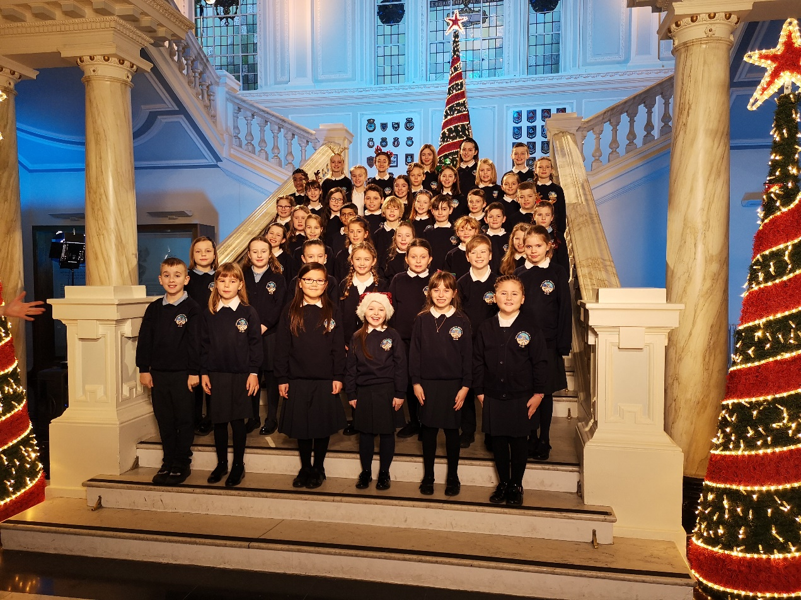
Attainment and Achievements

In this section we would ordinarily report on performance levels in literacy and numeracy determined by standardised test scores and end of key stage assessment.
Due to the disruption in the spring and summer term of 2020 standardised tests, usually administered in May were not completed and that data is not available.
While teachers have continued to assess indicative end of key stage levels during this school year, the disruption experienced during the spring and summer terms has meant that the use of such data as a summative expression of performance is not appropriate and we have deferred reporting on this until 2021.

New Build

Forge IPS was announced in March 2016 as one of a number of schools to have a new school built as part of the Fresh Start programme.
A Project Design Team, comprised of school staff, architects and design consultants and Education Authority Officials has met on a monthly basis to develop designs for the new build in readiness for a planning application and further progress towards construction.
A Project Board, comprised of representatives of school management and governors, the Education Authority, Design Consultants and the Department of Education has met regularly during the course of the year to oversee progress of the project.
The project has progressed significantly and a planning submission is likely during the 2020-21 school year.

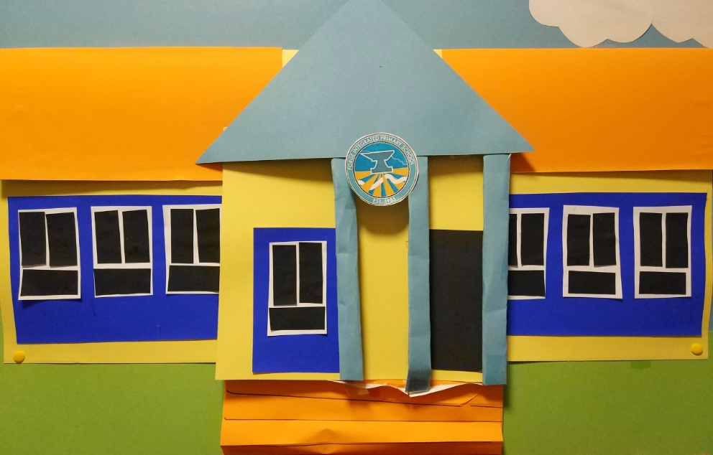
Community

The Board of Governors have encouraged, overseen and contributed to a number of community projects that the school has been involved with during the school year. These have included:

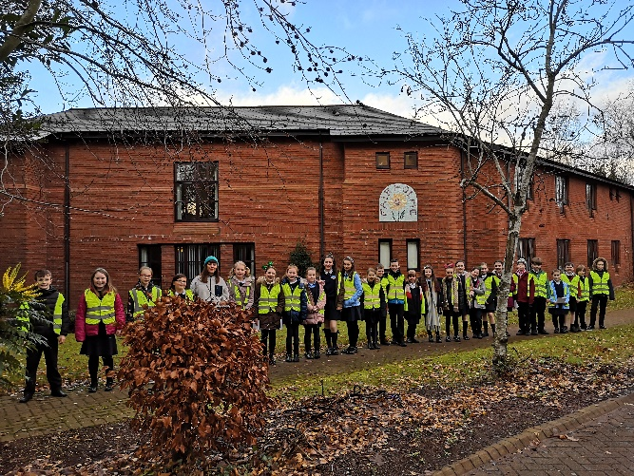
- The development of a cross generational project with Fairholme Supported Living
- Encouraging engagement with local political representatives from all parties
- Maintaining link with South Belfast Foodbank
- Maintaining Tradition with local Churches through churches trails and carol services
- Maintaining curricular links with other schools and Pre School settings through Eco Schools, Forest Schools, CRED, KS2/3 Transition and Pre-School/P1 Transition
- Partnership with Nerve Belfast to enhance learning in ICT
- Partnership with Business in the Community ‘Time to Read’ and Time to Code Schemes
- Supporting South Belfast Foodbank, Children in Need and the IEF.

Security, Safety and Safeguarding

The Board of Governors continue to oversee security and safety at the school and work with the Principal to address Health and Safety issues. The school has improved physical security in recent years through the installation of additional safety fencing, door access systems and CCTV. Emergency Plans are reviewed and updated regularly and regular evacuation and lock down drills are carried out. Two members of staff – The Principal and the Secretary are trained in First Aid up to First Aid at work standards and a significant number of teachers and assistants have completed emergency first aid training.

Safeguarding and Child Protection Policies and Practice are reviewed annually and a full review was conducted in Autumn 2020 and approved by the Board of Governors. There is a dedicated Safeguarding Governor who meets with the staff Safeguarding team and reports back to the Board of Governors. ETI inspectors visiting the school in 2016 found our Safeguarding arrangements to be comprehensive.

The governors have supported the implementation of a number of pastoral care initiatives including the Barnardos Paths Plus scheme, which includes a ‘Friendships Group’ and now a Paths Pals pupil support scheme, and the continued provision of counselling services for pupils through a contractual agreement with FamilyworksNI. Staff and pupils attended Anti Bullying Ambassadors training in 2019 and this is now being embedded as an aspect of the school’s pastoral care offering.

The school’s Child Protection Team consists of Ms. Mahon (Designated Teacher for Child Protection), Mrs. Kerr (Deputy Designated Teacher) and Mr. Watson (Principal). Mrs Claire Humphrey is the dedicated Safeguarding Governor.

All concerns and queries regarding child protection should be addressed in the first instance to Ms. Mahon or one of the other team members.

Safeguarding Policies and Procedures are available on the school website and on request from the school office.

Special Educational Needs

The Board of Governors continue to oversee the school’s policy and procedures on SEN and the Special Educational Needs Coordinator (SENCO), Ms D Mahon, reports to the Board of Governors on an annual basis. The School also employ a dedicated Learning Support Teacher (LST), Miss L MacKenna.

The school’s SEN and Inclusion policy was reviewed and approved by the Board of Governors in Autumn 2016 and is compliant with the 1996 SEN Order and the SEN Code of Practice. Special Needs vary as children move through school and children may be on the register for a period and then taken off following a period of intervention.

Children on the SEN register will have an Individual Education Plan (IEP) with specific targets and strategies to work towards achieving them.

A number of improvements to practice were embedded during 2018/19 including the further roll out of provision mapping for pupils on the SEN register, the inclusion on IEPs of pupil’s views and additional training for staff in Maths Recovery and working with children who may have had adverse childhood experiences, training which is feeding into current practice.

A total of pupils 84 pupils were on the special needs register at time of Census for the 2019 school year. This represents 21% of pupils, a 7% decrease on the previous year illustrating the dynamic nature of the challenge that catering for the variety of needs we have presents. The level of support offered to children is determined by individual needs and circumstances. Support in place for children includes:

  - Support from within school from our own part – time Learning Support Teacher.
  - Support from Harberton Language Unit outreach teacher and Harberton School
  - Support from a specialist hearing support teacher
  - Advisory support from Oakwood ASD Centre
  - Support from peripatetic teachers from EANI Fortwilliam Teacher’s Centre

The school’s accommodation remains accessible to all pupils and additional accommodation currently being constructed will be compliant with the most recent disability access regulations.

New guidance from the Education Authority implemented in the latter part of the 2018/19 school year has meant that some children are no longer on the SEN register and have now been moved to the Medical Register. Some children will have medical needs which impact their learning and will remain on both. However, for children whose medical condition is manageable and does not impact upon a child’s learning they will no longer be included on the SEN register.

Forge Staff

Teaching
Senior Leadership Team | Mr N Watson - Principal  Mrs G Kerr – Vice Principal & English  Ms D Mahon SENCO/DTCP  Mrs P McAleer - Assessment  Mrs S Gowan – Maths  Mrs J Foster - ICT | N/A  P5  P7  P4  P3  P1
Middle Leaders | Mrs J Mercer – PDMU  Mrs P Salmon – Eco-Schools  Mrs S Gray – Newcomers, Integration and Diversity  Miss S Houston - Music  Mrs L O’Malley – RE  Mrs S Rocks – PE  Miss A Masterson – Paths/PDMU  Miss C Mahon – Art  Mrs S Gamble – World Around Us  Mrs G Wood – Pupil Voice  Miss L MacKenna – Learning Support | P1  P2  P2  P3  P7  P3  P3  P4  P5  P6  P6  N/A
Non- Teaching
Classroom Support Staff/ Supervisory Staff | Ms J Heaney  Ms C Morsman  Ms J McLoughlin  Mrs A Kirk  Mrs C McConnell  Mrs R Maxwell | Mrs S Lyons  Mrs C Adams  Miss R Brown
Secretary | Miss K McStravick, Mrs E Farrell
Caretaking & Cleaning | Mr D Reid  Mrs G Whyte  Ms T Toner | Mrs B Jones
Catering | Mrs H Palmer  Ms T Toner | Mrs D Stelges  Mrs L Bain
Pre School Playgroup Staff
Mrs S Cherry - Leader
Ms S Veitch - Deputy Leader
Miss K Wilson - Playgroup Assistant
Mrs H Reid - Playgroup Assistant
Miss Sarah McKenna - Playgroup Assistant

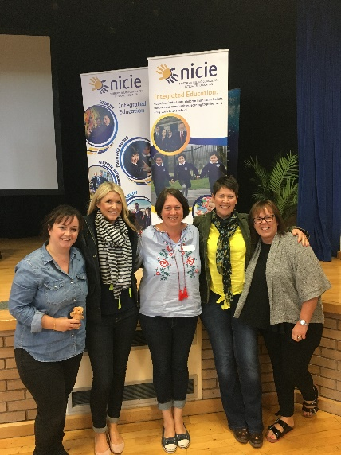
Our staff continue to engage in a broad range of professional development opportunities to feed into school improvement. The Board of Governors recognises the very significant contribution made by teachers and also by Non-Teaching staff in ensuring that Forge is a safe, positive and progressive place to learn.

Professional Development
Staff development, like many other aspects of school life, was adversely impacted by the Closure period of spring/summer 2020. Up until that point, staff engaged in after school meetings, in-service training at Education Authority centres and internally organised in-service days. Online training has continued and staff have availed of a number of online training seminars and meetings.
These involved programmes of professional development for staff/Curriculum Development including;

- Barnardos Paths Training for Classroom Assistants and Teachers  - Nerve Belfast ICT Training for Teachers  - Child Protection Refresher Training for Relevant Staff  - SENCO, ICT, Literacy & Numeracy Clusters  - First Aid training for key staff | - Assessment Analysis  - Anti-Bias Training for recently appointed staff

Contributing to External Teacher Training and Development
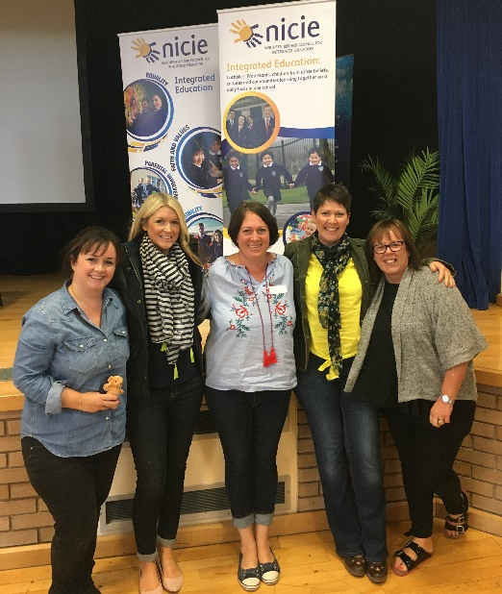
The school has accommodated students during the year - including trainee teachers from Stranmillis College and the University of Ulster and work experience students from Wellington and Lagan Colleges. We also assisted with aspects of teacher training/Development for Stranmillis College and NICIE.
Our ability to accommodate students working towards qualifications in the fields of childcare and education has been hampered although not entirely impeded by the Coronavirus situation.

Pre School
Mrs Stephanie Cherry has continued to lead the Pre-School team who continue to develop the Pre-School which has again enjoyed full capacity this school year. The Board of Governors acknowledges the solid work done by the Pre-School team and the voluntary Pre-School Management Committee in giving our children the best start to their education.

Parental Engagement

The Governors acknowledge the high levels of parental engagement through home learning, attendance at curriculum information meetings and individual Parent/Teacher Meetings held in October and February. Parents contributed with enthusiasm to initiatives such as Maths Week and Workshops on Linguistic Phonics, Mental Maths and various other aspects of the curriculum were also well attended.

The school has continued to develop home school communication through use of social media pages on Facebook and Twitter, a static website and the phased introduction of See Saw which has now been extended up to P5 has been very valuable in enabling parents and pupils to engage with remote learning during the closure period of 2020 and continues to be used extensively for home learning. Microsoft Teams has been adopted by P6 and 7 as a platform to engage pupils with remote learning. A gradual switch from use of paper notes sent home via ‘schoolbag post’ to email has been ongoing and an emergency SMS service has been maintained for urgent notifications.

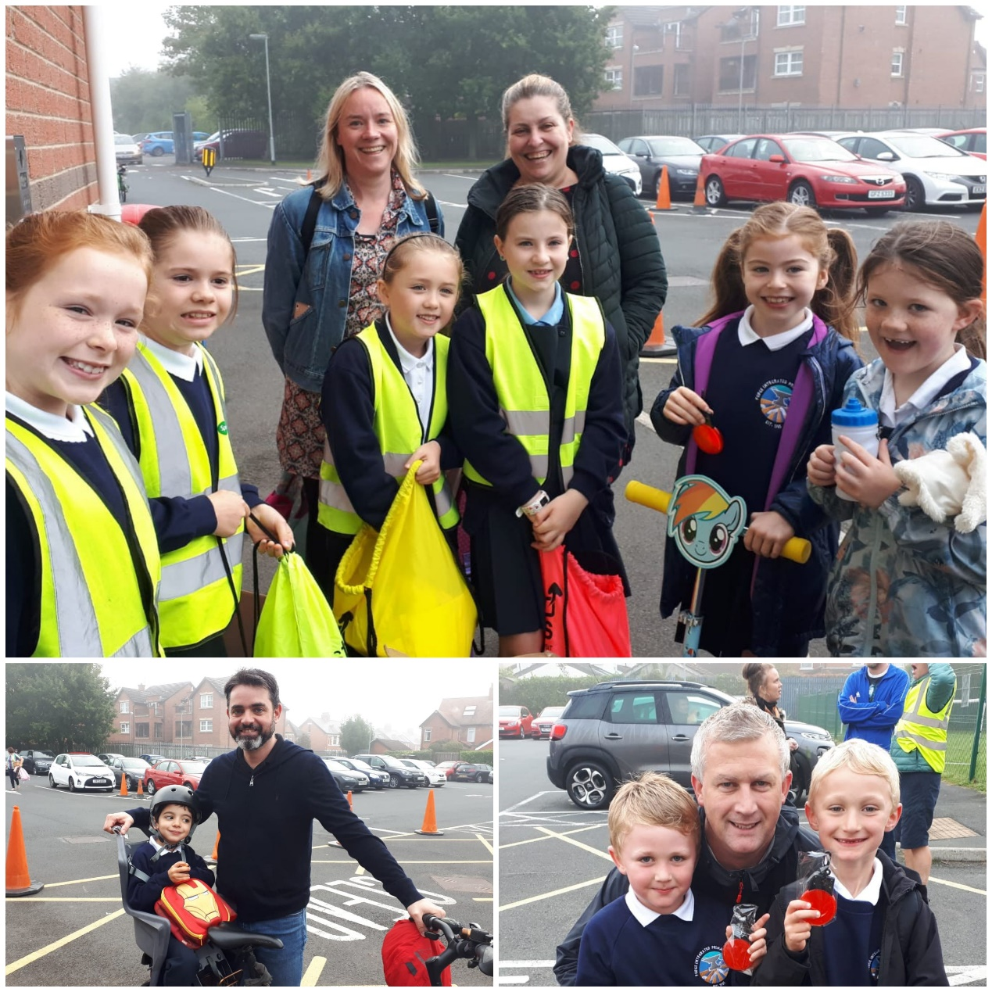

The Parent Teacher Association (PTA) has been a valuable body providing support to the school through fundraising and through social events. Despite some of the key annual events held in the latter part of the school year having been cancelled due to Covid-19 restrictions the PTA have continued to plan and contribute to school life.

Pupils
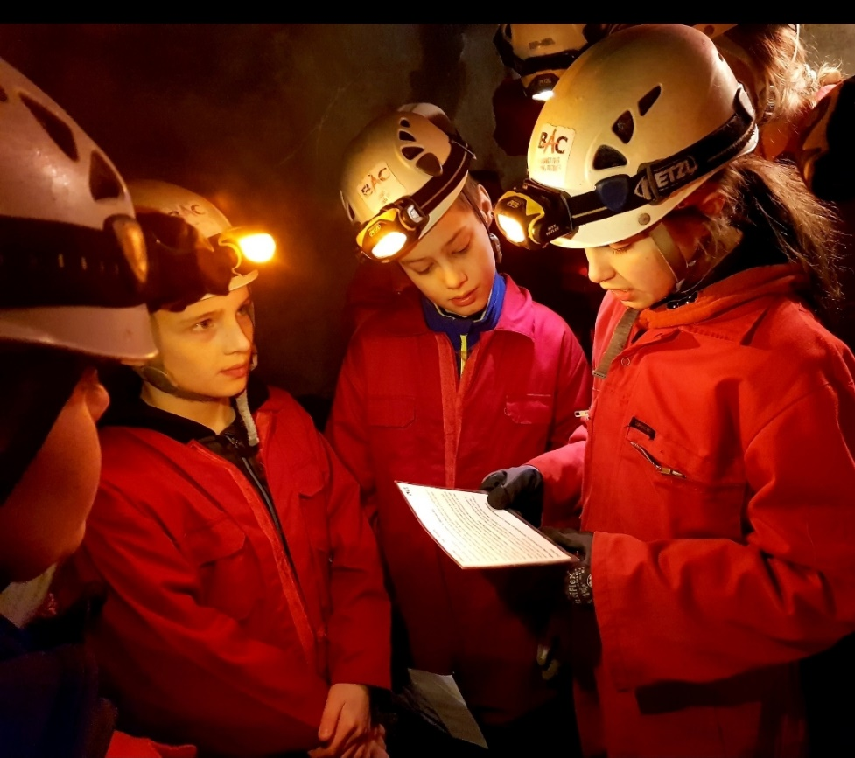
The Board of Governors recognise that pupils are at the heart the school. We congratulate our current pupils and leavers on their successes in every sphere of life.

Attendance at school was distorted very significantly due to the closure period of spring and summer 2020 with the majority of pupils learning from home. It is therefore not possible to provide attendance data this school year that can readily be compared to previous years.

We recognise the value of the very broad and holistic nature of learning at Forge where classroom learning is supplemented by well-structured, field trips, visitors to the school, residential experiences and participation in sporting, arts and cultural events.
It was therefore disappointing to be unable to deliver a number of key learning events this year including both P6 and P7 residential trips due to the Covid-19 situation. It was some comfort to have been able to provide P7 pupils with the excellent ‘Adventure Investigators’ programme with Belfast Activity Centre in January and February 2020, before the impact of the pandemic took hold.

The School Development Plan and School Development Plan Evaluation offer a more comprehensive overview of the current and ongoing work of the school and can be viewed on the school website www.forgeips.co.uk.
The very significant disruptive impact of Covid-19 will mean that out school development will not be delivered in full or on time as currently planned. Although a situation such as we are currently experiencing bring great adversity, it is also a time of innovation and we intend to review and update development planning in February 2021 to reflect this.
Beyond Forge

The 2019/20 school year saw 44 pupils transfer to post primary education. Lagan College continues to be the most popular (46%) destination school for transferors but we have also seen a broad range of destination schools. A number of parents entered their children for the Association for Quality Education (AQE) Common Entrance Assessment as used by most controlled and voluntary grammar schools and/or the Post Primary Transfer Consortium (PPTC) GL Entrance Assessment, as used by most Maintained Grammar Schools and Lagan College. There were also a number of pupils who did not participate in any selection tests.

2018 | No.  Pupils | %  Total | 2019 | No.  Pupils | %  Total | 2020 | No. Pupils | % Total
Lagan College | 22 | 48% | Lagan College | 36 | 70% | Lagan College | 20 | 46%
Wellington College | 4 | 9% | Wellington College | 1 | 2% | Grosvenor Grammar school | 1 | 2%
Methodist College | 5 | 11% | Methodist College | 2 | 4% | Hazelwood Integrated College | 1 | 2%
Victoria College | 2 | 4% | Aquinas Diocesan Grammar | 2 | 4% | Malone College | 4 | 9%
St Josephs’ College | 4 | 9% | St Josephs’ College | 2 | 4% | Methodist College | 1 | 2%
Campbell College | 0 | 0% | Campbell College | 2 | 4% | St Joseph’s College | 6 | 14%
Malone College | 1 | 2% | Grosvenor Grammar School | 2 | 4% | St Louise’s Comprehensive | 1 | 2%
RBAI | 0 | 0% | Strathern School | 1 | 2% | Victoria College | 1 | 2%
Grosvenor Grammar School | 1 | 2% | Blessed Trinity College | 1 | 2% | Wellington College | 9 | 21%
Our Lady & St Pat’s Coll | 1 | 2% | Unplaced | 1 | 2% | Total | 44 | 100%
Bloomfield Collegiate | 1 | 2% | Total | 51 | 100%
Blessed Trinity College | 1 | 2%
St Louise’s Comprehensive | 1 | 2%
Crumlin Integrated College | 1 | 2%
Down High School | 1 | 2%
Unplaced | 1 | 2%
Total | 46 | 100%
Post Primary Schools Transferred to by Forge P7 leavers:

Finance - School LMS (Local Management of Schools) Budget

Schools are given a budget so that they can plan spending to meet the priorities they have identified.

The initial budget for the financial year ended 31 March 2019 was set by the Education Authority based on the Common Funding Formula.

The Board of Governors monitor and plan expenditure with the Principal. The school ended the 2019 financial year with a small surplus. This has been possible thanks to support from the Integrated Education fund to help offset costs that come with pupil growth and also due to some incidental factors such as changes in staff. The combined pressures of budget reductions and escalating costs will make the next few years very challenging. We will need to continue to spend carefully and avail of all additional funding opportunities to maintain resource levels into the foreseeable future.

The table below shows 2019 - 20 budget balanced against expenditure.

Fiscal Year: 2019 Fiscal Period: Apr19 –Mar20

Total Available Budget | 1,093,973
 | Expenditure
Income Total (includes grants, rental income) | -16,587
Staff - Pay Teaching Total | 876,819
Staff - Pay Non-Teaching Total | 155,416
Staff - Other Costs Total | 78
Premises, Fixed Plant & Gds Total | 40,333
Operating costs Total | 30,886
Non capital purchases Total | 999
Re-allocations Total | 7,040
Capital Expenditure Total | -7,217
Grand Total | 1,087,811
Year End Position | 6,162

Financial Outlook 2020 – 2023

It is important to understand that schools are required to plan spending over a three-year period and surpluses and deficits are planned to try to keep staffing and resource levels adequate, while also keeping the budget at levels which are manageable.

Deficit figures are shown in brackets.

Financial Year | 2020/21 | 2021/22 | 2022/23
Total Estimated Budget Available (income) | 1,147096 | 1,164382 | 1,151823
Total Estimated Expenditure | 1,128013 | 1,143163 | 1,151823
Year-end surplus/(deficit) | 25245 | 46464 | 61493
% Surplus/Deficit | 2.2 | 3.9 | 5.1

School Funds (Non LMS) Balance Sheet & Income/Expenditure.

The tables below represent the balance and transactions on the school’s private funds. In common with most schools we maintain accounts to service day to day transactions and to manage fundraising and non LMS spending. We also maintain account for use as a hardship fund through which we plan to finance initiatives such as in school counselling for pupils and a contingency fund, which allows us to cope with unforeseen pressures such as additional costs for staff due to unforeseen circumstances and the essential replacement of large items of equipment due to unforeseen failure – for example interactive whiteboards.

These accounts are subject to external independent examination by a chartered accountant (RWCA Ltd.) on an annual basis.

