13 December 2018

Dear parent/Carer,

As we hurtle towards Christmas we are fine tuning arrangements for the last week of term – please note the information below and have a look at your own Christmas ‘TO DO’ list to see if everything fits!

Christmas Plays P1-4
We are putting on additional performances of P1 & P2 Christmas Plays to facilitate demand.
The revised schedule is:

P1 Little Blue Star
Wed 19 Dec: 0930am (Sold Out)
Thurs 20 Dec: 1030am (Tickets Available)

P2 Snowmen at Sunset
Wed 19 Dec: 1015am (Sold Out)
Thurs 20 Dec: 1115am (Tickets Available)

P3/4 It’s a Party
Performance 1 Wed 19 Dec 1.30pm (Last few seats)
Performance 2 Thurs 20 Dec 9.30am (Last few seats)

Last Day of Term 21 December 2018

P1 & P2 pupils will finish school for Christmas at 12pm on Friday 21st December 2018 and can be collected at school at 12pm.

Carol Service P3 - 7
Our Carol Service This Year will be held on Friday 21st December 2018 at St John’s Presbyterian Church, Knockbreda from 11.00am – 12.00pm. Children will walk to the church, led by teachers.
Parents and carers are invited to join us at the church and children can be taken home by their parents from the church at 12pm. Alternatively we will walk children back to the school where they can be collected at approximately 1215pm. If you do intend to collect your child directly from the church, please ensure that their teacher is informed so that we can tick their name from the register to avoid any confusion!

We do sometimes have to change and adapt the plans for these events – if that happens we’ll try to get information updated via email and on our social media pages as soon as possible.

Yours Sincerely,
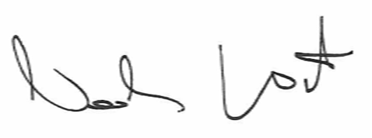
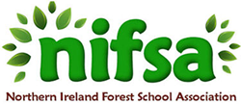
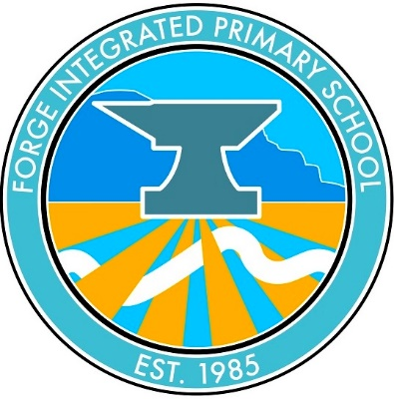
Principal
20 Carolan Road
Belfast
BT73HE
Telephone 02890492177
Email info@forge.belfast.ni.sch.uk
www.forgeips.co.uk

Principal Mr N Watson

